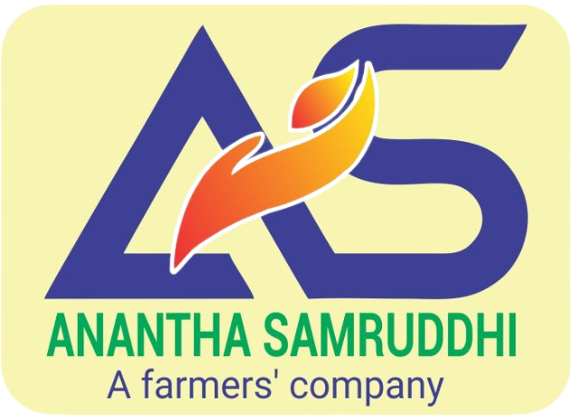
RYTHU NESTHAM FOOD PRODUCER COMPANY LIMITED
Manufacturing and Marketing of Millet and Groundnut-based Value-added Foods under the Brand “Anantha Samruddhi”
PROJECT PERIOD: 2019 – FEBRUARY 2023

Rythu Nestham Food Producer Company Limited (RNFPCL) is a women-led Farmer Producer Company (FPC) established in 2019 with the objective of creating sustainable livelihood opportunities for smallholder farmers through value addition, processing, and marketing of climate-resilient crops, particularly millets and groundnuts. The company was promoted with the technical support of the International Crops Research Institute for the Semi-Arid Tropics (ICRISAT) and the facilitation of Accion Fraterna Ecology Centre (AFEC), Anantapur. The company represents farmers from nine Farmer Producer Organisations (FPOs) across eight mandals of Anantapur district, thereby creating an integrated farmer-owned agribusiness enterprise.
RNFPCL markets its products under the brand “Anantha Samruddhi”, reflecting the vision of bringing prosperity to the drought-prone Anantapur region through nutritious, value-added food products.
GENESIS OF THE PROJECT
Recognising the need to improve farm incomes and enhance nutritional security in rainfed regions, ICRISAT designed a comprehensive value-chain development programme covering production, primary processing, secondary processing, product development, branding, and market linkages. The initiative was implemented with financial assistance from the Walmart Foundation as part of its CSR programme.
The project aimed to increase farmers' incomes through value addition, promote climate-resilient crops, create rural employment (especially for women), improve nutrition, and establish a sustainable farmer-owned food processing enterprise.
ESTABLISHMENT OF A MANUFACTURING FACILITY
A modern secondary food processing unit worth approximately ₹5 crore was established at Mudulapuram village in Anantapur district by ICRISAT under the Walmart Foundation-supported nutrition project. The facility produces millet flour, ready-to-cook mixes, ready-to-eat snacks, groundnut products, cookies, savouries, and cold-pressed groundnut oil, while adhering to FSSAI quality standards.
PRODUCT PORTFOLIO
- Multi-millet flour and millet mixes
- Ragi, foxtail millet and little millet products
- Groundnut chikki, cookies and savouries
- Cold-pressed groundnut oil
BUSINESS PERFORMANCE
Annual turnover has shown encouraging growth, reflecting increasing consumer acceptance and expanding market reach:
FY 2024-25  ₹18 lakh | FY 2025-26  ₹37 lakh
▲ nearly 94% growth in annual turnover
SOCIAL AND ECONOMIC IMPACT
- Improved farmer incomes
- Strengthened women-led enterprises
- Generated rural employment
- Promoted climate-resilient agriculture
- Enhanced nutrition awareness
- Established a farmer-owned branded food business
FUTURE POTENTIAL
RNFPCL has strong potential to expand into modern retail, e-commerce, institutional markets, exports, and new value-added product categories as demand for millet-based foods continues to grow.
CONCLUSION
RNFPCL is an excellent example of farmer-owned agribusiness supported by ICRISAT, AFEC, and the Walmart Foundation. The ₹5-crore processing facility and the Anantha Samruddhi brand have created a sustainable model for value addition, improved farmer incomes, women's empowerment, nutrition promotion, and climate-resilient rural development. The increase in annual turnover from ₹18 lakh to ₹37 lakh demonstrates the enterprise's growing commercial viability.
Anantha Samruddhi • Rythu Nestham Food Producer Company Limited • Anantapur, Andhra Pradesh

